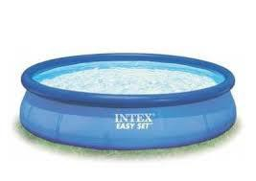

kL
1 kiloliter = ? liter
1 kl = ? m3

kL
1 kiloliter = 1000 liter
1 kl = 1 m3

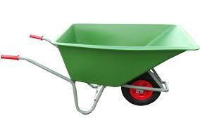

hL
1 hectoliter = ? liter

hL
1 hectoliter = 100 liter

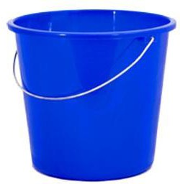

daL
1 decaliter = ? liter

daL
1 decaliter = 10 liter

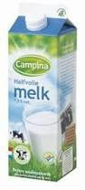

L
1 liter
1 l = ? dm3

L
1 liter
1 l = 1 dm3

dL
1 deciliter = ? liter

dL
1 deciliter = 0,1 liter

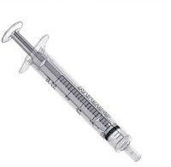

cL
1 centiliter = ? liter

cL
1 centiliter = 0,01 liter

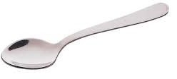

mL
1 milliliter = ? liter
1 ml = ? cm3

mL
1 milliliter = 0,001 liter
1 ml = 1 cm3

